* Function apps are create just like webapps but the different is choice of plan type in them. <https://docs.microsoft.com/en-us/azure/azure-functions/functions-overview>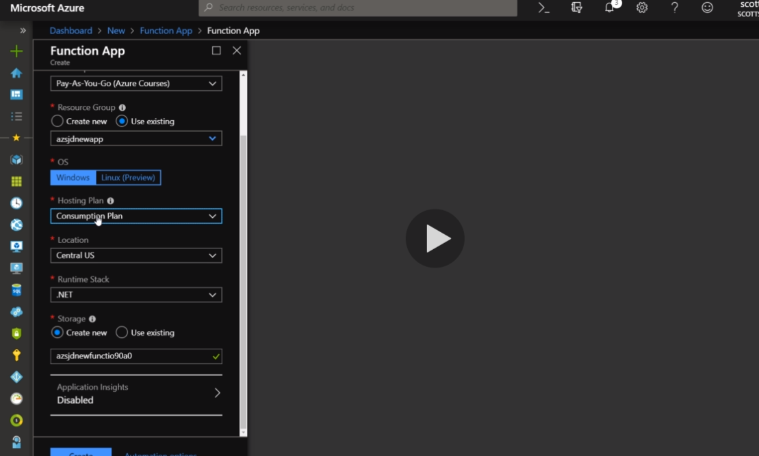

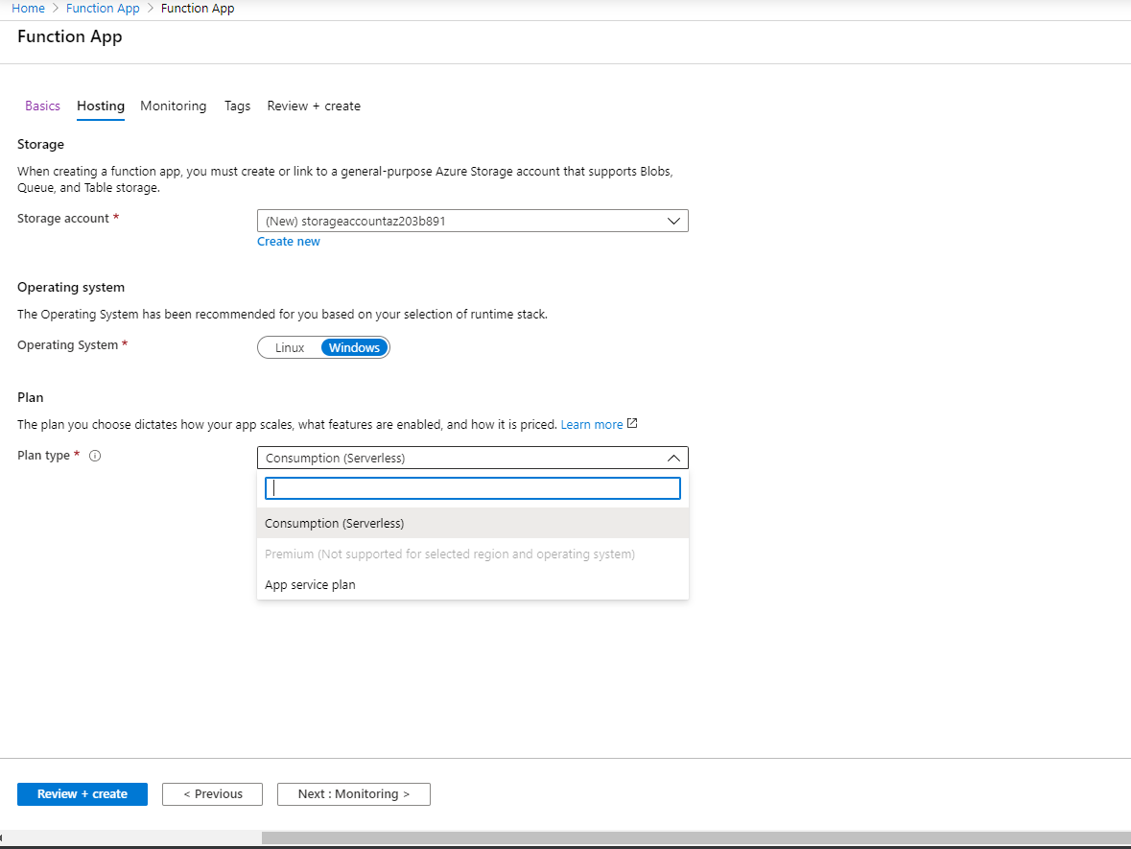

* There should be a different app service plan for windows and linux, though it can be used b/w web and function app.
* Function for this app can created developed and tested right within the azure portal. 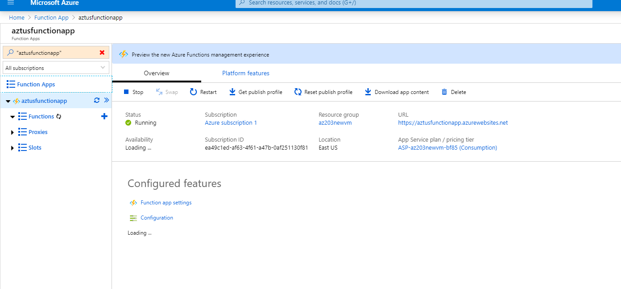
* Microsoftprovides template and env for function creation.
* We are not able to develop in Azure portal when we have java function app.
* Chosing the inportal function to demonstrate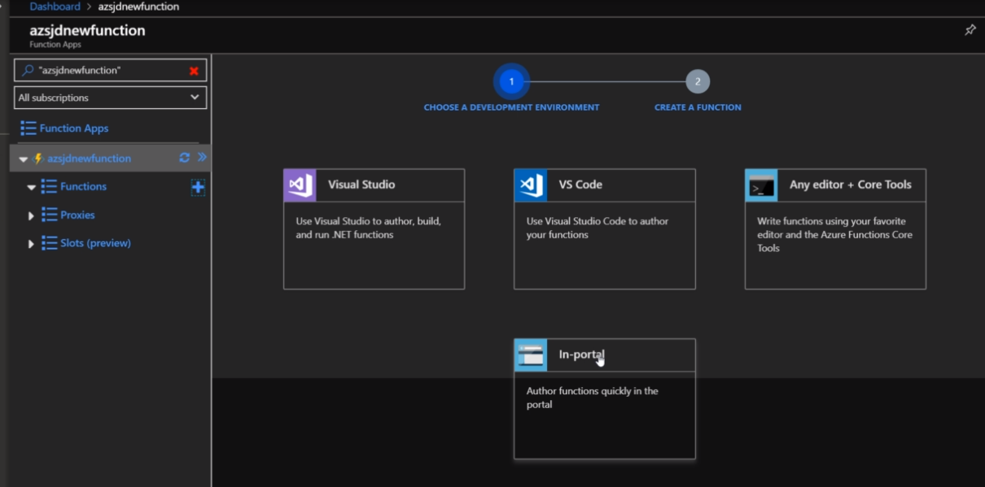
* We have some basic template to start from while doing inportal function.
* All functions must have a trigger just like aweb job will have a cron time trigger.
* Any function must have just 1 trigger 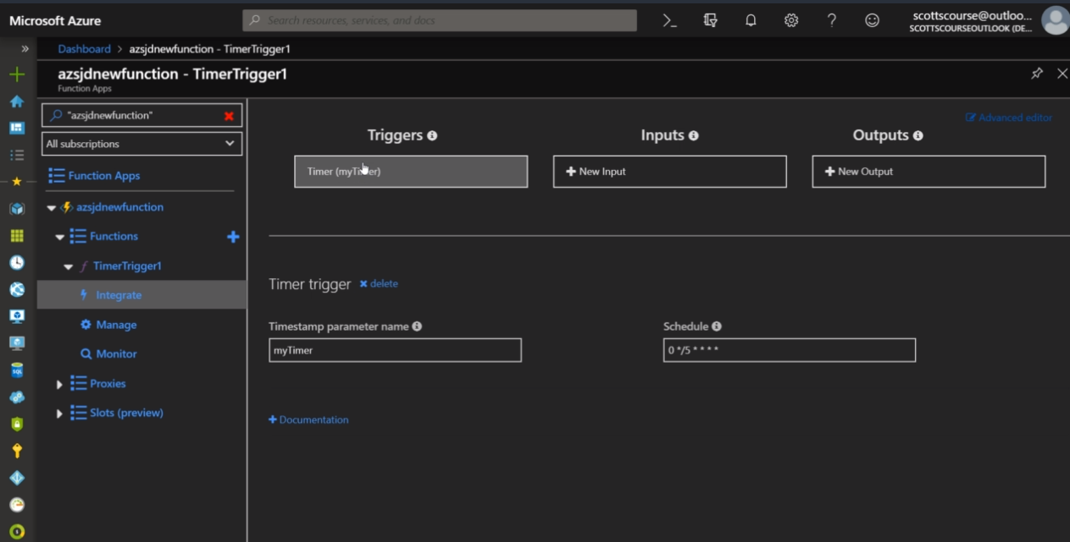
* For storage it will notify us to have a storage entension.
* We add out output blob to save the outputblob of the function like this. 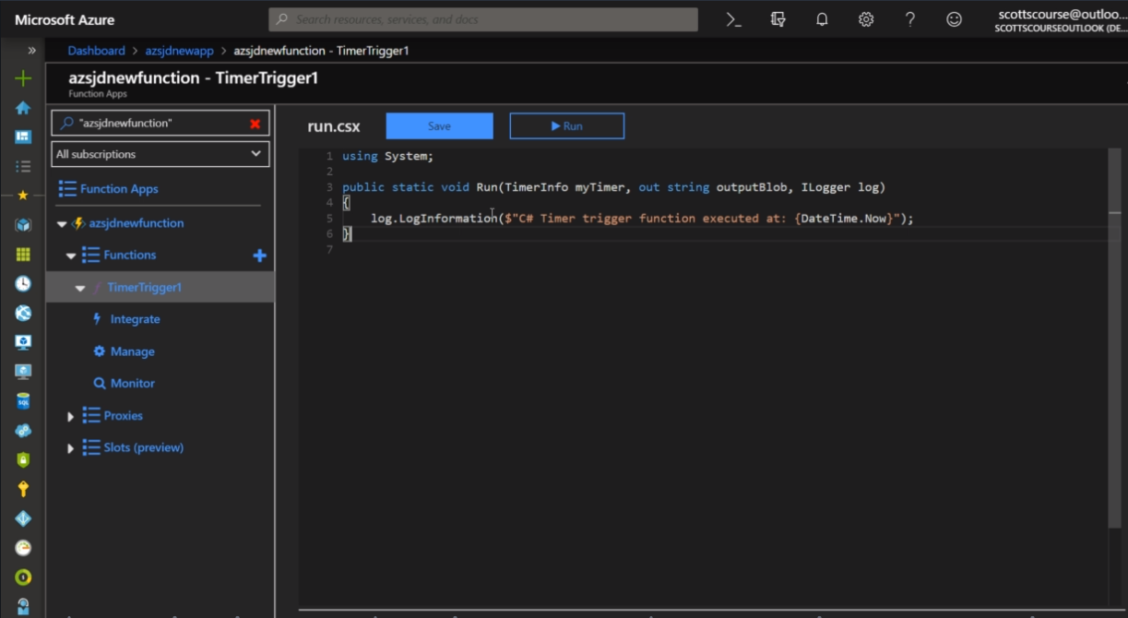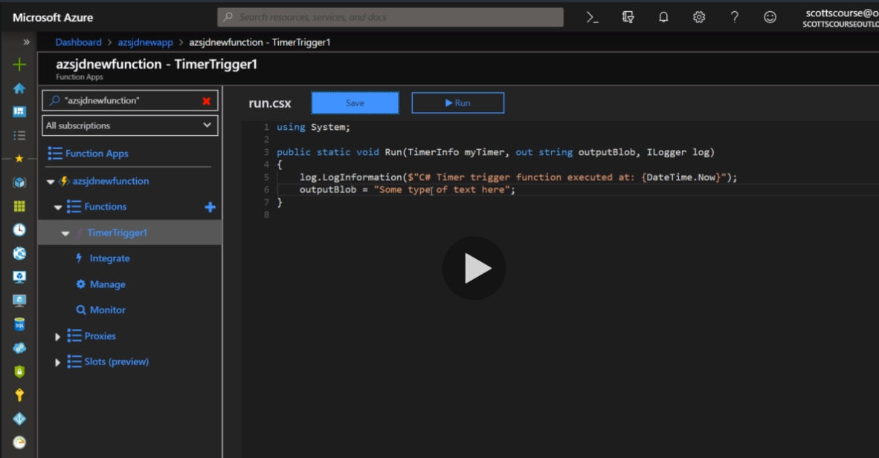
* When we run the execution happens right within the portal and code is executed successfully. 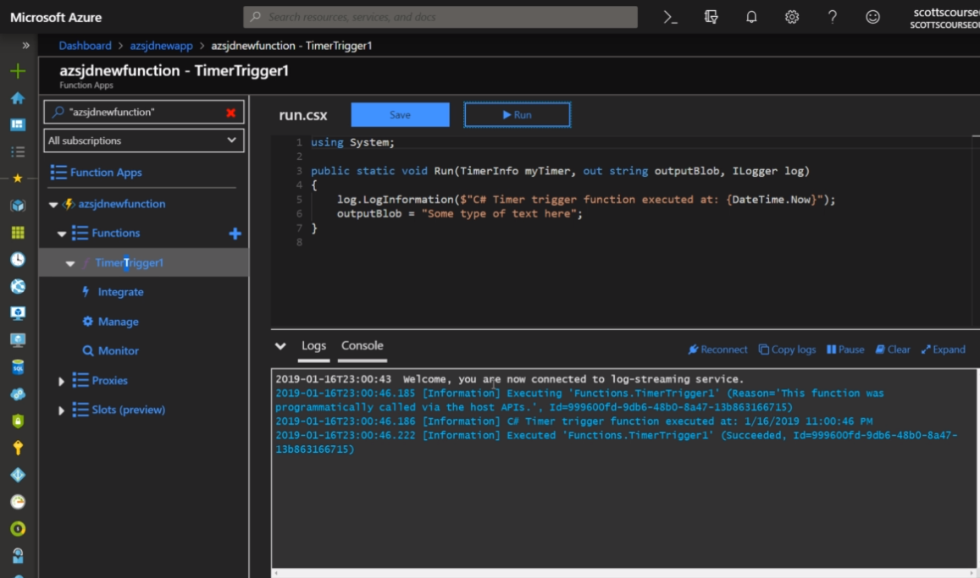
* We can aslo go in the storage account in the container to check if the output came in it or not. Download it locally and we will see the blob there 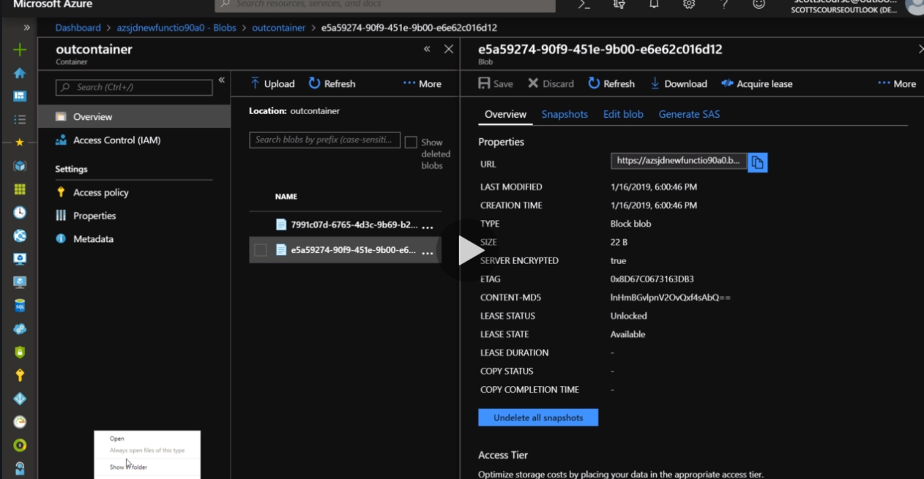
* Timer info will inable the function to run every 5 minutes as that is its trigger, we can also disable the timer when we want in b/w.
* Functions are self-contained code to run inside of azure portal.